**Word Count Program With MapReduce and Java**

In Hadoop, MapReduce is a computation that decomposes large manipulation jobs into individual tasks that can be executed in parallel cross a cluster of servers. The results of tasks can be joined together to compute final results.

MapReduce consists of 2 steps:

• **Map Function –**It takes a set of data and converts it into another set of data, where individual elements are broken down into tuples (Key-Value pair).

**Example –**(Map function in Word Count)

|  |  |  |
| --- | --- | --- |
| **Input** | Set of data | Bus, Car, bus,  car, train, car, bus, car, train, bus, TRAIN,BUS, buS, caR, CAR, car, BUS, TRAIN |
| **Output** | Convert into another set of data  (Key,Value) | (Bus,1), (Car,1), (bus,1), (car,1), (train,1),  (car,1), (bus,1), (car,1), (train,1), (bus,1),  (TRAIN,1),(BUS,1), (buS,1), (caR,1), (CAR,1),  (car,1), (BUS,1), (TRAIN,1) |

• **Reduce Function –**Takes the output from Map as an input and combines those data tuples into a smaller set of tuples.

**Example –**(Reduce function in Word Count)

|  |  |  |
| --- | --- | --- |
| **Input**  **(output of Map function)** | Set of Tuples | (Bus,1), (Car,1), (bus,1), (car,1), (train,1),  (car,1), (bus,1), (car,1), (train,1), (bus,1),  (TRAIN,1),(BUS,1), (buS,1), (caR,1), (CAR,1),  (car,1), (BUS,1), (TRAIN,1) |
| **Output** | Converts into smaller set of tuples | (BUS,7),  (CAR,7),  (TRAIN,4) |

**Work Flow of Program**

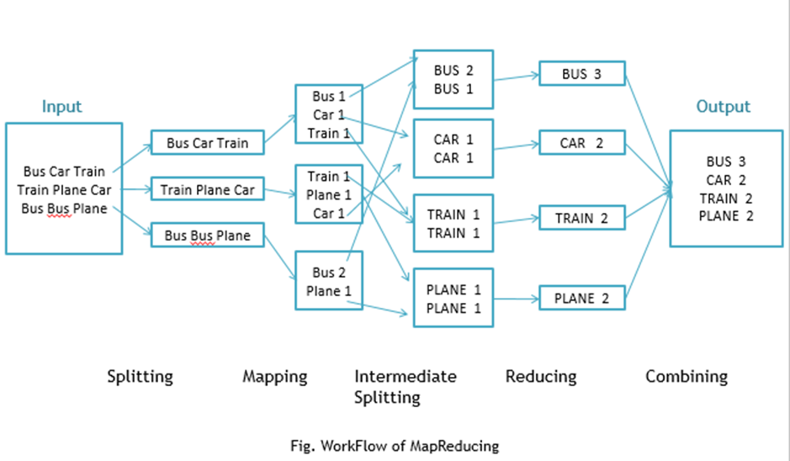

Workflow of MapReduce consists of 5 steps

1. **Splitting** – The splitting parameter can be anything, e.g. splitting by space, comma, semicolon, or even by a new line (‘\n’).
2. **Mapping** – as explained above
3. **Intermediate splitting** – the entire process in parallel on different clusters. In order to group them in “Reduce Phase” the similar KEY data should be on same cluster.
4. **Reduce** – it is nothing but mostly group by phase
5. **Combining** – The last phase where all the data (individual result set from each cluster) is combine together to form a Result

**Now Let’s See the Word Count Program in Java**

Fortunately we don’t have to write all of the above steps, we only need to write the splitting parameter, Map function logic, and Reduce function logic. The rest of the remaining steps will execute automatically.

Make sure that Hadoop is installed on your system with java idk

**Steps**

Step 1.  Open Eclipse> File > New > Java Project >( Name it – MRProgramsDemo) > Finish

Step 2.  Right Click > New > Package ( Name it - PackageDemo) > Finish

Step 3. Right Click on Package > New > Class (Name it - WordCount)

Step 4. Add Following Reference Libraries –

Right Click on Project > Build Path> Add External Archivals

* */usr/lib/hadoop-0.20/***hadoop-core.jar**
* *Usr/lib/hadoop-0.20/lib/***Commons-cli-1.2.jar**

Step 5. Type following Program :

package PackageDemo;

import java.io.IOException;

import org.apache.hadoop.conf.Configuration;

import org.apache.hadoop.fs.Path;

import org.apache.hadoop.io.IntWritable;

import org.apache.hadoop.io.LongWritable;

import org.apache.hadoop.io.Text;

import org.apache.hadoop.mapreduce.Job;

import org.apache.hadoop.mapreduce.Mapper;

import org.apache.hadoop.mapreduce.Reducer;

import org.apache.hadoop.mapreduce.lib.input.FileInputFormat;

import org.apache.hadoop.mapreduce.lib.output.FileOutputFormat;

import org.apache.hadoop.util.GenericOptionsParser;

public class WordCount {

public static void main(String [] args) throws Exception

{

Configuration c=new Configuration();

String[] files=new GenericOptionsParser(c,args).getRemainingArgs();

Path input=new Path(files[0]);

Path output=new Path(files[1]);

Job j=new Job(c,"wordcount");

j.setJarByClass(WordCount.class);

j.setMapperClass(MapForWordCount.class);

j.setReducerClass(ReduceForWordCount.class);

j.setOutputKeyClass(Text.class);

j.setOutputValueClass(IntWritable.class);

FileInputFormat.addInputPath(j, input);

FileOutputFormat.setOutputPath(j, output);

System.exit(j.waitForCompletion(true)?0:1);

}

public static class MapForWordCount extends Mapper<LongWritable, Text, Text, IntWritable>{

public void map(LongWritable key, Text value, Context con) throws IOException, InterruptedException

{

String line = value.toString();

String[] words=line.split(",");

for(String word: words )

{

Text outputKey = new Text(word.toUpperCase().trim());

IntWritable outputValue = new IntWritable(1);

con.write(outputKey, outputValue);

}

}

}

public static class ReduceForWordCount extends Reducer<Text, IntWritable, Text, IntWritable>

{

public void reduce(Text word, Iterable<IntWritable> values, Context con) throws IOException, InterruptedException

{

int sum = 0;

for(IntWritable value : values)

{

sum += value.get();

}

con.write(word, new IntWritable(sum));

}

}

}

**Explanation**

The program consist of 3 classes:

* Driver class (Public void static main- the entry point)
* Map class which **extends** public class Mapper<KEYIN,VALUEIN,KEYOUT,VALUEOUT>  and implements the Map function.
* Reduce class which extends public class Reducer<KEYIN,VALUEIN,KEYOUT,VALUEOUT> and implements the Reduce function.

Step 6. Make Jar File

Right Click on Project> Export> Select export destination as **Jar File** > next> Finish

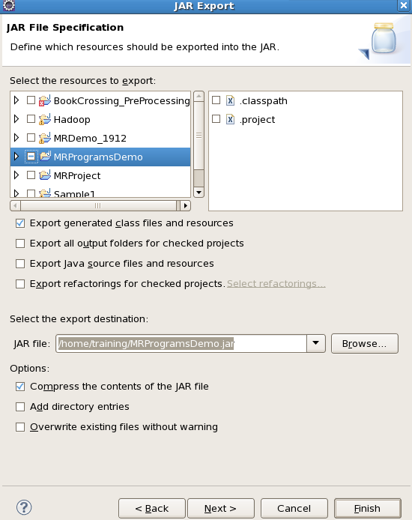

Step 7: Take a text file and move it in HDFS

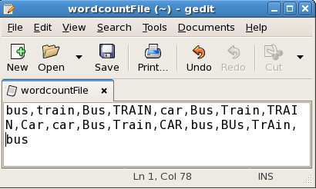

To Move this into Hadoop directly, open the terminal and enter the following commands:

[training@localhost ~]$ hadoop fs -put wordcountFile wordCountFile

Step 8 . Run Jar file

*(hadoop jar jarfilename.jar packageName.ClassName  PathToInputTextFile PathToOutputDirectry)*

[training@localhost ~]$ hadoop jar MRProgramsDemo.jar PackageDemo.WordCount wordCountFile MRDir1

Step 9. Open Result

[training@localhost ~]$ hadoop fs -ls MRDir1

Found 3 items

-rw-r--r-- 1 training supergroup 0 2016-02-23 03:36 /user/training/MRDir1/_SUCCESS

drwxr-xr-x - training supergroup 0 2016-02-23 03:36 /user/training/MRDir1/_logs

-rw-r--r-- 1 training supergroup 20 2016-02-23 03:36 /user/training/MRDir1/part-r-00000

[training@localhost ~]$ hadoop fs -cat MRDir1/part-r-00000

BUS 7

CAR 4

TRAIN 6

**Source : https://dzone.com/articles/word-count-hello-word-program-in-mapreduce**